SOLAR SOLUTIONS: OUTDOOR AIR PURIFIER FIGHTING AGAINST URBAN POLLUTION

SAI TEJ PAGADALA *Department of EIE  
VR Siddhartha Engineering College,*

*Vijayawada, India*

[saipagadala18@gmail.com](mailto:saipagadala18@gmail.com)

DHANESH ARIGE  
 *Department of EIE*

*VR Siddhartha Engineering College,*  
*Vijayawada, India* [arigedhanesh2003@gmail.com](mailto:arigedhanesh2003@gmail.com)

G. JALALU

*Asst. Professor, Department of EIE*  
*VR Siddhartha Engineering College,*

*Vijayawada, India*

[jallu.sk@vrsiddhartha.ac.in](mailto:jallu.sk@vrsiddhartha.ac.ingmail.com)

SATYA RAM CHARAN KUMMARI   
 *Department of EIE*

*VR Siddhartha Engineering College,*  
*Vijayawada,India* [satyacharankummari45@gmail.com](mailto:satyacharankummari45@gmail.com)

GOUTHAM KUMAR VADDI

*Department of EIE*

*VR Siddhartha Engineering College,*

*Vijayawada, India*[gouthamkumarvaddi@gmail.com](mailto:gouthamkumarvaddi@gmail.com)

ABSTRACT— Solar outdoor air purifiers represent an innovative and sustainable solution to combat air pollution by harnessing renewable solar energy for purification processes. These devices utilize photovoltaic panels to generate electricity from sunlight, powering advanced filtration and ionization mechanisms that effectively remove pollutants such as particulate matter, volatile organic compounds, and harmful gases from the atmosphere. Their versatility and adaptability make them suitable for various environmental settings, while integration with smart monitoring systems enhances operational efficiency. By promoting cleaner air outdoors without generating greenhouse gas emissions, solar outdoor air purifiers offer a promising pathway towards mitigating the adverse effects of air pollution on human health and the environment.

**Keywords**— Solar energy, Air purification, Photovoltaic panels, Renewable energy, Pollution mitigation, pm2.5, heap filter, mq2 dust sensor **.**

## I . INTRODUCTION

In the face of escalating concerns regarding air pollution and its detrimental impacts on human health and the environment, the development of sustainable solutions has become paramount. Solar outdoor air purifiers emerge as a promising innovation in this endeavor, offering a unique blend of renewable energy utilization and advanced air purification technology. This introduction sets the stage for exploring the concept, significance, and potential of solar outdoor air purifiers as an effective means to mitigate air pollution and promote cleaner environments.

Rapid urbanization, industrialization, and transportation .have significantly contributed to the deterioration of air quality in many regions worldwide. The resulting increase in airborne pollutants, including particulate matter, volatile organic compounds (VOCs), and various harmful gases, poses serious health risks and environmental challenges. Addressing these issues requires innovative approaches that not only reduce pollution but also embrace sustainability principles. Solar outdoor air purifiers represent a convergence of two key elements: solar energy and air purification technology. By harnessing the abundant and renewable energy of the sun, these devices power advanced purification processes aimed at removing contaminants from the outdoor atmosphere. The utilization photovoltaic panels enables autonomous operation without relying on conventional energy sources, thereby reducing carbon emissions and promoting environmental sustainability.

The effectiveness of solar outdoor air purifiers lies in their ability to target a wide range of pollutants, including both particulate and gaseous pollutants. Advanced filtration systems, such as high-efficiency particulate air (HEPA) filters and activated carbon filters, ensure thorough removal of airborne particles and odors, while ionization processes neutralize pathogens and allergens, further enhancing air quality.

Moreover, the versatility and adaptability of solar outdoor air purifiers make them suitable for various environmental settings, including urban areas, industrial zones, and public spaces. Their modular designs enable easy installation and scalability, allowing for tailored deployment based on specific air quality needs. Integration with smart monitoring and control systems facilitates real-time data analysis and management, enhancing operational efficiency and ensuring optimal performance.

II. LITERATURE SURVEY

"Solar-Powered Air Purifiers: A Review of Technologies and Applications"[1].This comprehensive review article provides an overview of various solar-powered air purifier technologies, including their design, operation principles, and applications.

It discusses the efficacy of solar energy utilization in driving air purification processes and examines the potential benefits and challenges associated with solar outdoor air purifiers.

"Advancements in Photovoltaic Integration for Solar Air Purification Systems"[2].

This research paper explores recent advancements in photovoltaic integration for solar air purification systems. It investigates the design considerations, performance optimization techniques, and practical implementation aspects of solar-powered air purifiers, highlighting the role of photovoltaic technology in enhancing energy efficiency and sustainability.” Evaluation of Solar Outdoor Air Purifiers for Urban Air Quality Improvement" [3].

This study assesses the effectiveness of solar outdoor air purifiers in improving urban air quality. Through field experiments and monitoring campaigns, it quantifies the reduction in particulate matter, VOCs, and other pollutants achieved by solar-powered air purification systems in real-world environments. The findings contribute to understanding the potential impact of such technologies on public health and environmental sustainability. "Integration of Smart Monitoring Systems in Solar Outdoor Air Purifiers"

This paper investigates the integration of smart monitoring systems in solar outdoor air purifiers to enhance operational efficiency and performance optimization. It discusses the design and implementation of sensor networks, data analytics platforms, and remote control mechanisms for real-time monitoring and management of air quality parameters, offering insights into the potential applications of IoT technology in sustainable air purification solutions. “Life Cycle Assessment of Solar Outdoor Air Purifiers: Environmental Impacts and Sustainability Analysis"[4].

This research assesses the environmental impacts and sustainability implications of solar outdoor air purifiers through a life cycle assessment (LCA) approach. It evaluates the energy consumption, greenhouse gas emissions, and resource utilization associated with the production, operation, and disposal phases of solar-powered air purification systems, providing valuable insights into their overall environmental footprint and potential for reducing environmental burdens. "Economic Analysis of Solar Outdoor Air Purifiers: Cost-Benefit Evaluation and Market Potential"[5].

This study conducts an economic analysis of solar outdoor air purifiers to evaluate their cost-effectiveness, economic viability, and market potential. It examines the upfront investment, operational costs, and potential savings associated with deploying solar-powered air purification systems, considering factors such as energy savings, health benefits, and environmental externalities. The findings provide valuable insights for policymakers, investors, and stakeholders interested in promoting sustainable air quality management solutions. “Community Engagement and Stakeholder Perspectives on Solar Outdoor Air Purifiers"[6].

This research explores community engagement strategies and stakeholder perspectives on the adoption and implementation of solar outdoor air purifiers. Through surveys, interviews, and participatory workshops, it assesses public awareness, acceptance, and perception of solar-powered air purification technologies, identifying key factors influencing community engagement and decision-making processes. The insights generated contribute to fostering public acceptance and support for sustainable air quality improvement initiatives[7] .

## III. PROPOSED SYSTEM

“In this project paper, we present a groundbreaking proposed system poised to redefine the landscape public safety. Our innovative approach integrates cutting- edge technologies and strategic methods to provide a holistic solution for over coming challenges in reducing air pollution. Join us as we delve into the details of our proposed system , show casing it’s capacity to propel research , enhance efficiency, and contribute to the on going development of air free countries.

The incorporation of all components onto an Arduino Uno Board not only ensures cost-effectiveness but also facilitates seamless interaction. The Arduino IDE is utilized for programming the Arduino Board. The Block diagram of proposed model as shown in Fig.1.

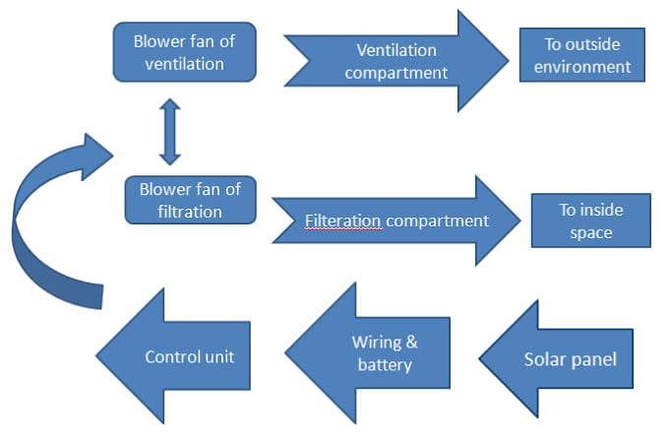

Fig .1. Block Diagram of Proposed model.

## A. Hardware and software



Various types of sensors and indicators were connected to Arduino Uno board. Arduino board acts as heart of the project and makes it less complex. The Arduino Uno is as depicted in Fig.2. is based on the ATmega328P microcontroller, which is an 8-bit AVR microcontroller with 32KB of flash memory for storing program.

It operates at a clock speed of 16MHZ. The board has 14 digital input/output pins. Among these, 6 can be used as PWM (Pulse Width Modulation) outputs. There are 6 analog input pins on the Arduino Uno, labeled A0 through A5. The Arduino Uno has a UART for serial communication interfaces. Arduino Integrated Development Environment (IDE), which simplifies the process of writing, compiling, and uploading code to the board.

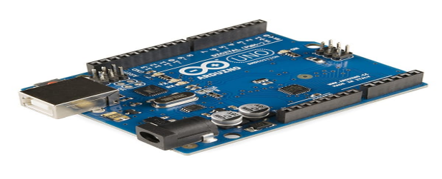

Fig.2. Arduino UNO Board

PM 2.5 sensor :

The 2.5 in PM 2.5 refers to the size of the pollutant, in micrometers. The tinniest thing which the human eye can see is at least 0.1 millimeters, about the width of a strand fine air (70 micrometers). For you to see something as small as a micrometer, you need to use microscopes. “Fine” particulate matter as 2.5 PM is referred to by health agencies and pollution experts, possesses one attribute that makes them particularly dangerous . These just penetrate your lungs. They are also small enough to pass directly into your bloodstream . Though invisible to the naked eye, the air we breathe is located with tiny particulate made up of chemicals, allergens, dust, smoke, or soil in the form of (microscopic) solids, gasses or liquids.

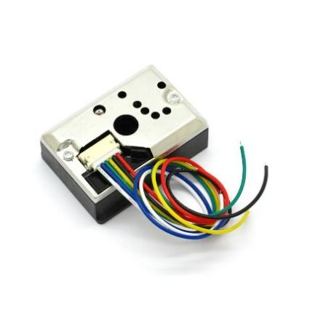

Fig. 3. PM 2.5 Sensor

Air Quality sensor:

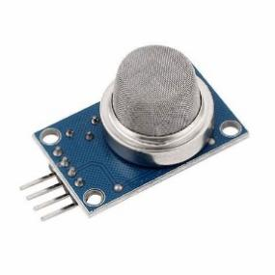

Fig. 4. Air quality Sensor

The MQ2 is a heater-driven sensor . It is therefore covered with two layers of fine stainless stee l mesh known as an “anti-explosion network”. It ensures that the heater element inside the sensor does not an explosion because we are sensing flammable gasses.

When a Sno2 semiconductor layer is heated to a high temperature, oxygen is adsorbed on the surface. When the air is clean electronics from conduction band of tin dioxide are attracted to oxygen molecules. This crates an electron depletion layer just beneath the surface of the SnO2 particles, forming a potential barrier. As a result, the SnO2 film becomes highly resistive and prevents electric current flow.

HEPA filter :

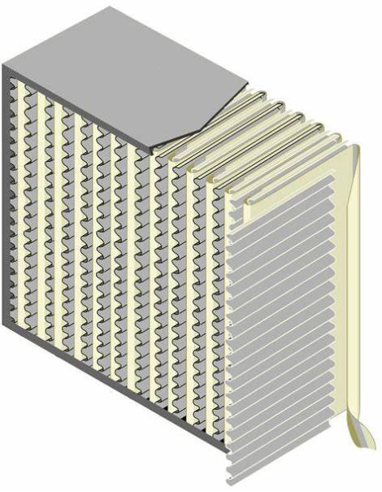

Fig.5. HEPA filter

Filters meeting the HEPA standard must satisfy certain levels of efficiency. Common standards require that a HEPA air filter must remove—from the air that passes through—at least 99.95% (ISO, European Standard) or 99.97%(ASME, U.S.DOE) of particles whose diameter is equal to 0.3 um, with the filtration efficiency increasing for particle diameters both less than and greater than 0.3 μm. HEPA filters capture pollen, dirt, dust, moistur,bacteria(0.2.0 μm), virus (0.02–0.3 μm),and submicron liquid aerosol (0.02–0.5 μm).As depicted in Fig.4 HEPA filter is illustrated.

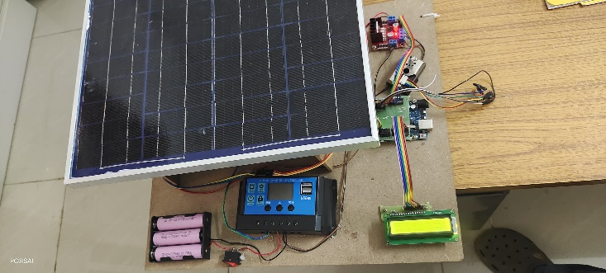

Fig.6. The Proposed System

Software :

The Arduino programming typically involves using a simplified version of C++ with additional Libraries and functions offered by the Arduino framework. The Arduino microcontroller is programmed using the Arduino IDE (Integrated Development Environment). We develop the necessary C++ program for the project using the Arduino programming environment, and then upload it onto the Arduino microcontroller. This program interfaces with sensors, controls a fans operation, and manages filtration linked to system. The proposed system as shown in Fig.5.

## IV. RESULTS

In the envisioned setup depicted in Fig.7. The project’s proposed system takes form. During the initial phase of testing as illustrated in Fig.7.and Fig.8. The prototype receives supply of power from the solar rechargeable batteries and the power is supplied to all sensors and suction, exhaust fans through the Arduino Uno board to PM2.5 sensor and Dust sensor. As shown in Fig.9. the process starts based on the count of PM2.5 particles sensed by PM2.5 sensor . As per the code dumped in Arduino Uno the suction and exhaust fans start running. Fig.10. shows the end result of process showing content before purification and after purification .

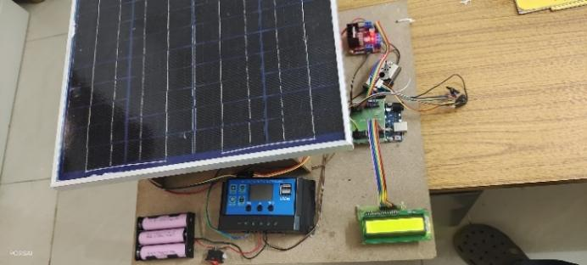

Fig.7. Prototype of solar outdoor air purifier

* 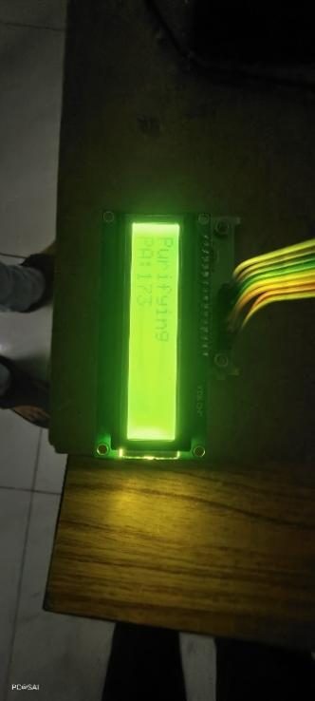

Fig.8. Lcd display of purification content

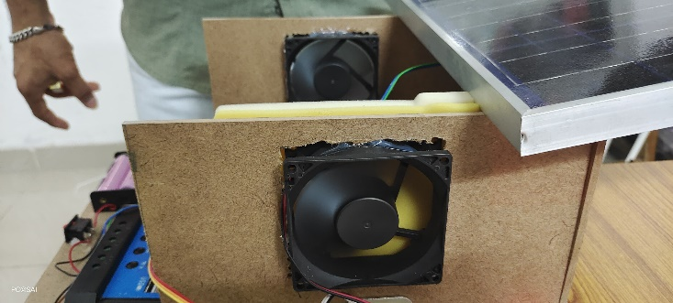

Fig.9. Filteration in processing

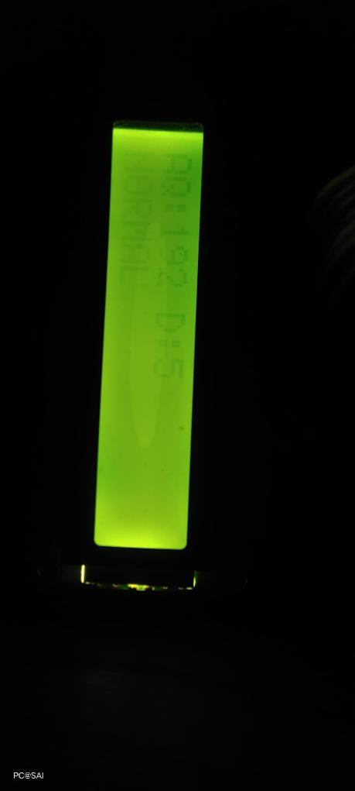

Fig.10. Result of pollution content

## V. FUTURE WORK

Solar outdoor air purifiers entails a multifaceted approach aimed at advancing their efficiency, applicability, and impact. Firstly, research should focus on enhancing filtration technologies to improve pollutant removal efficiency, addressing a wide range of contaminants such as particulate matter, volatile organic compounds (VOCs), and gases. Concurrently, efforts should be directed towards integrating energy storage systems, like batteries or capacitors, to ensure continuous operation during periods of low solar irradiance, thereby maximizing air purification efficacy. Moreover, optimizing photovoltaic systems through novel materials and configurations is crucial to boost energy generation and maintain sustainable operation. Additionally, the development of smart monitoring and control systems leveraging sensors and machine learning algorithms can dynamically adjust purifier operation based on real-time air quality data and energy availability, optimizing performance and energy efficiency.

Secondly, future research should explore innovative urban integration strategies, such as incorporating solar outdoor air purifiers into existing infrastructure like streetlights or building facades, to maximize their impact on urban air quality while minimizing space requirements. Furthermore, comprehensive health impact assessments are imperative to evaluate the long-term effects of these purifiers on public health outcomes, guiding evidence-based policy decisions.

Life cycle assessments are essential to assess the environmental footprint of solar outdoor air purifiers comprehensively, ensuring their overall sustainability and minimizing unintended ecological consequences. Economic analyses and market studies are vital to assess cost-effectiveness, financial viability, and market potential, facilitating wider adoption and market penetration. Finally, fostering global collaboration and knowledge sharing is essential to accelerate innovation, exchange best practices, and scale up deployment, thereby advancing the role of solar outdoor air purifiers as a sustainable solution to air pollution on a global scale.

## VI. CONCLUSION

In conclusion, the future trajectory of solar outdoor air purifiers rests on multifaceted advancements in technology, urban integration, health assessments, environmental evaluations, economic analyses, and global cooperation. Enhanced filtration, energy storage integration, and optimized photovoltaics will boost efficiency, while smart monitoring systems will refine performance. Urban integration strategies will maximize impact, and thorough health and environmental assessments will ensure sustainability. Economic analyses are essential for broader adoption, alongside global collaboration to accelerate innovation and deployment. Through these concerted efforts, solar outdoor air purifiers stand poised to significantly ameliorate air quality, protect public health, and mitigate the global challenge of air pollution.

## REFERENCES

1. P. Singh et al., "Application of Air Purifier Drone to Control Air Pollutants in Domestic and Industrial Areas," 2020 International Conference on Electrical and Electronics Engineering (ICE3), 2020, pp. 676-679, doi:10.1109/ICE348803.2020.9122807.
2. Sharon, Frederic, et al. Leap-Solar (air Purifier). Diss. CMR Institute of Technology. Bangalore, 2020”.
3. www.aqi.in\in.
4. Perumal, D., et al. "SOLAR INDOOR AIR-PURIFIER WITH AIR QUALITY MONITOR SYSTEM.".
5. D. -H. Kim, M. -S. Kim and H. -J. Kim, "Micro dust removing by using Li+ batteries and Super cap parallel connection," 2018 International Conference on Information and Communication Technology Robotics (ICT-ROBOT), 2018, pp. 1-3.
6. M. B. Marinov, D. I. Iliev, T. S. Djamiykov, I. V. Rachev and K. K. Asparuhova, "Portable Air Purifier with Air Quality Monitoring Sensor," 2019 IEEE XXVIII International Scientific Conference Electronics (ET), 2019, pp. 1-4 .
7. M. Sharma, A. Kumar and A. Bachhar, "I2P air purifier with air quality monitoring device," 2017 2nd International Conference on Communication and Electronics Systems (ICCES), 2017, pp. 478-481, doi:10.1109/CESYS.2017.8321326.